Title (Times New Roman, bold, 16 pts)
Optional: sub-title (Times New Roman, bold, 14 pts)
Firstname Surname ^{1*§}, Firstname Surname ^{2§}, etc …

¹ Address author 1 (left-aligned)
² Address author 2 (left-aligned)
If all the authors have the same address, it will be centered.
* Corresponding author; email: …………………
Optional: § co-first authors (The Bulletin SRSL allows for max. 2 co-first authors.)

Abstract
The whole document is formatted with Times New Roman font and 1.15 line spacing. The font size used should be 12 throughout except in certain titles. Text paragraphs are justified to the left and right margins.
Keywords: separated by commas
Mathematics Subject Classification codes: only for articles in the field of mathematics

Résumé (optional)
The résumé starts with the title in French, in bold type. A French translation of the title, abstract and keywords may be provided.
Mots-clés : keywords in French, separated by commas

1. Level 1 title (Times New Roman, bold, 14 pts)
The submitted file must include line numbers for the convenience of the reviewers. The line numbering will be removed in the version to be published. The publisher will add (i) a header with the bibliographic reference including the DOI, (ii) page numbers, (iii) a line with the dates of submission and acceptance and (iv) mention of the open access Creative Commons CC BY 4.0 license.

1.1. Level 2 title (Times New Roman, bold, 12 pts)
All paragraphs in the main text are indented by about 0,7 cm. The figures and tables should be placed close to the paragraph where they are mentioned for the first time. They might be moved by the publisher during the final formatting
Footnotes or endnotes are not permitted.

1.1.1. Level 3 title (Times New Roman, italics, 12 pts)
Mathematical equations involving “multi-level” typography must appear on separate lines :

1.1.1.1. Level 4 title (Times New Roman 12 pts)
References are listed alphabetically by the first author’s last name, with in-text citation in (Author, Year) style. Alternatively, the references can be numbered in order of appearance in the text [1]. All common formats of references are accepted, but consistency throughout the reference list is required. If the bibliography is software-generated, convert it to standard text before submission.

Acknowledgments
This section is optional.

Further information
ORCID identifiers of authors
This section is optional.
Author contributions
This section is mandatory. The contributions of each author (identified by his/her initials) must be described. We recommend the CRediT taxonomy (Contributor Roles Taxonomy).
Conflicts of interest
This section is mandatory. Authors must declare any personal or professional circumstances that may be perceived as influencing the research reported in the paper. If there is no conflict of interest, please state "The authors declare no conflict of interest."

Supporting information (optional)
If Supporting Information files are made available to readers, the contents of each file are briefly described in this section.

References
The whole reference section is left-aligned. When available, the DOI link (or other persistent link) is provided at the end of the reference. If referencing a website, the access date must be provided.

Author, A., Author, B. and Author, C. (year) Article title. Journal name, volume(issue), xxx-yyy. https://doi.org/10.25518/0037-9565.9136

[1] Author, A., Author, B. and Author, C. (year) Article title. Journal name, volume(issue), xxx-yyy. https://doi.org/10.25518/0037-9565.9136

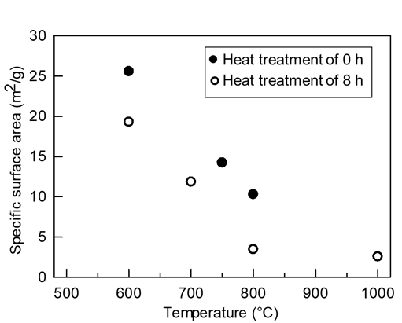
Figure 1. Example of a figure. The figure is centered. If any, the text/symbols/curves are large or broad enough to be easily legible. The authors may be contacted by the publisher if changes in the format or resolution of the figure are needed. Figures made up of several parts should be provided as a single file. The legend is centered if it consists of a single line. If not, the legend is justified to left and right margins removed by 2 cm from the main text margins.

Table 1: Example of table formatting. The legend is centered if it consists of a single line. If not, the legend is justified to left and right margins aligned with the table. A simple structure is recommended for tables. Please bear in mind that in the html version, the text in each cell will be left-aligned. More complex tables will be treated as figures to safeguard their structure.
Column 1 | Column 2 | Column 3 | Column 4
abc | 123 | 456 | 789
abc | 123 | 456 | 789
abc | 123 | 456 | 789

